# **Personal Data Protection Consent Form**

1. In compliance with Laws, R Systems International Ltd. seeks your consent to collect and use your personal data (i.e. Name, contact numbers, mailing addresses, email addresses) in order to maintain employee records, verifications and to disclose such personal data to R Systems’s affiliates or customers / prospects and other business purposes for necessary purposes.
2. R Systems respects your privacy and assures that your personal data will be kept securely according to Indian Law.
3. I hereby give my acknowledgement and consent to R Systems to use my personal data for the aforesaid purposes and services.
4. I agree that my consent will remain in place until my withdrawal by officially notifying R Systems in writing.

Name: Gaurav Gupta

Employee Code: 15476

Contact No.: 9811164837

Personal Email: gauravgupta1012@gmail.com

Signature: 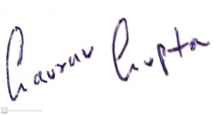

Date: 07-11-2022